Lesson Plan
Title | Programming with Python
Time duration | 1 Hour
Review & Exercises | Review of concepts and exercises for practice

Lesson Review
- Data structures:
  - Lists
  - Lists: when print a subset of the list this does not overwrite the original list. Instead it creates a new list that gets printed.

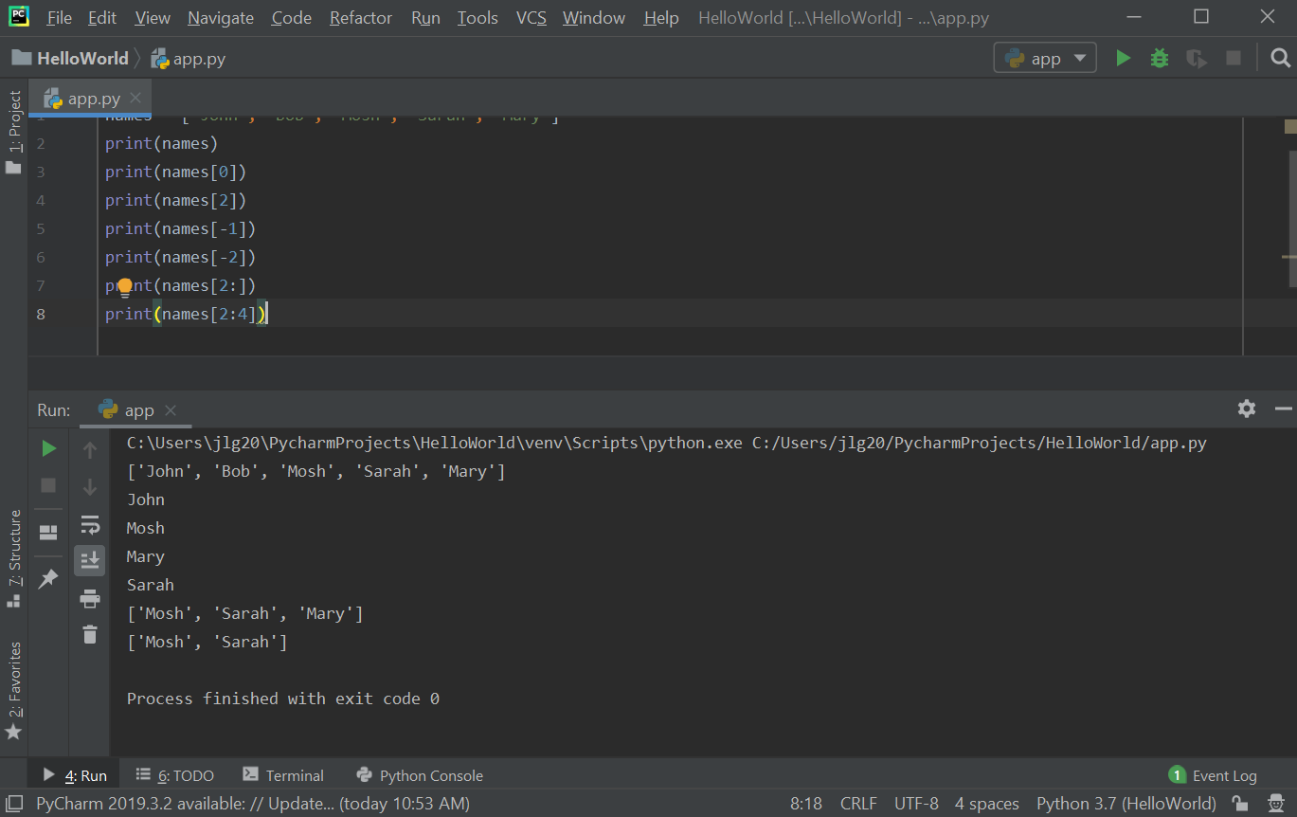

Values in the list can be modified using the index for that value.

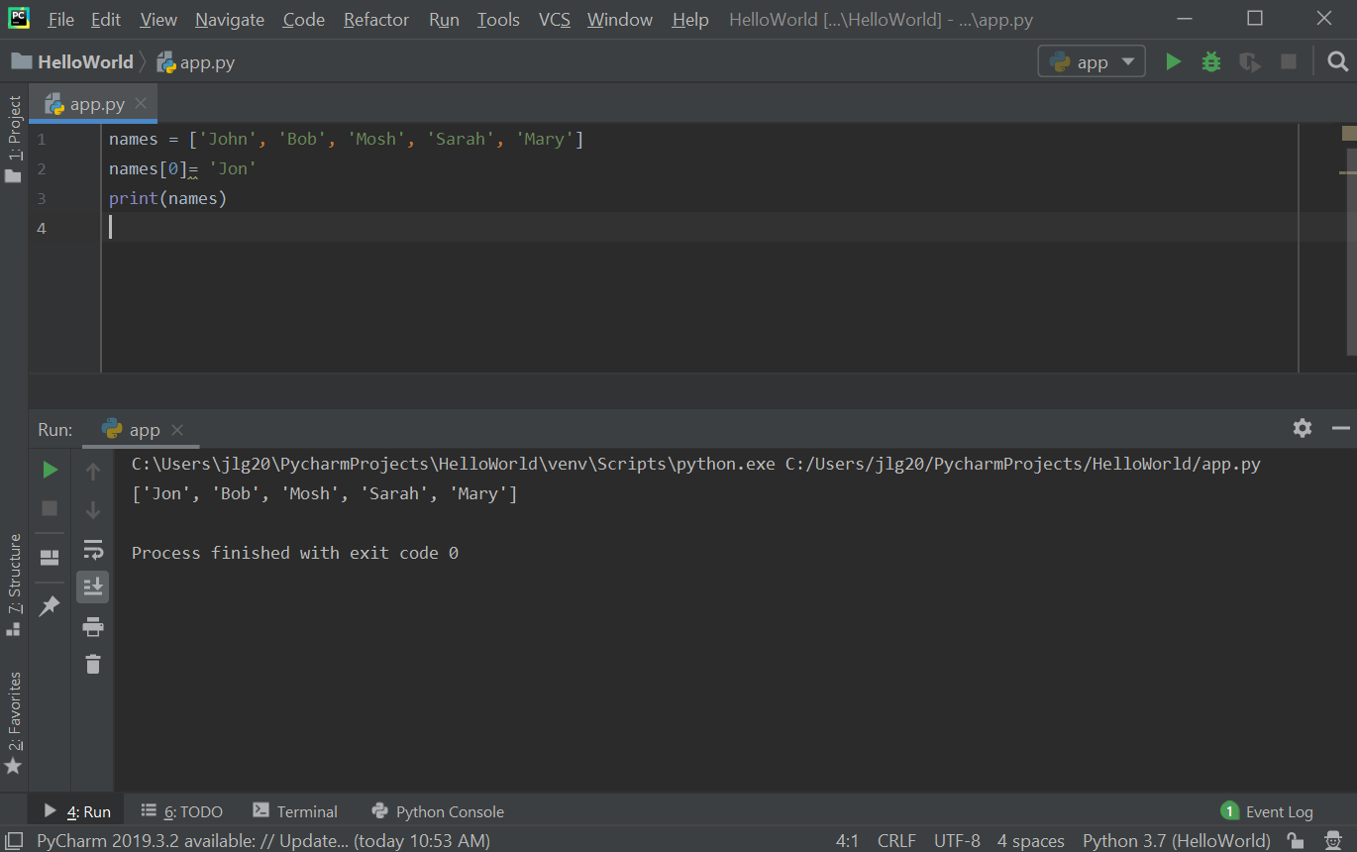

Exercise: write a program to find the largest number in a list.
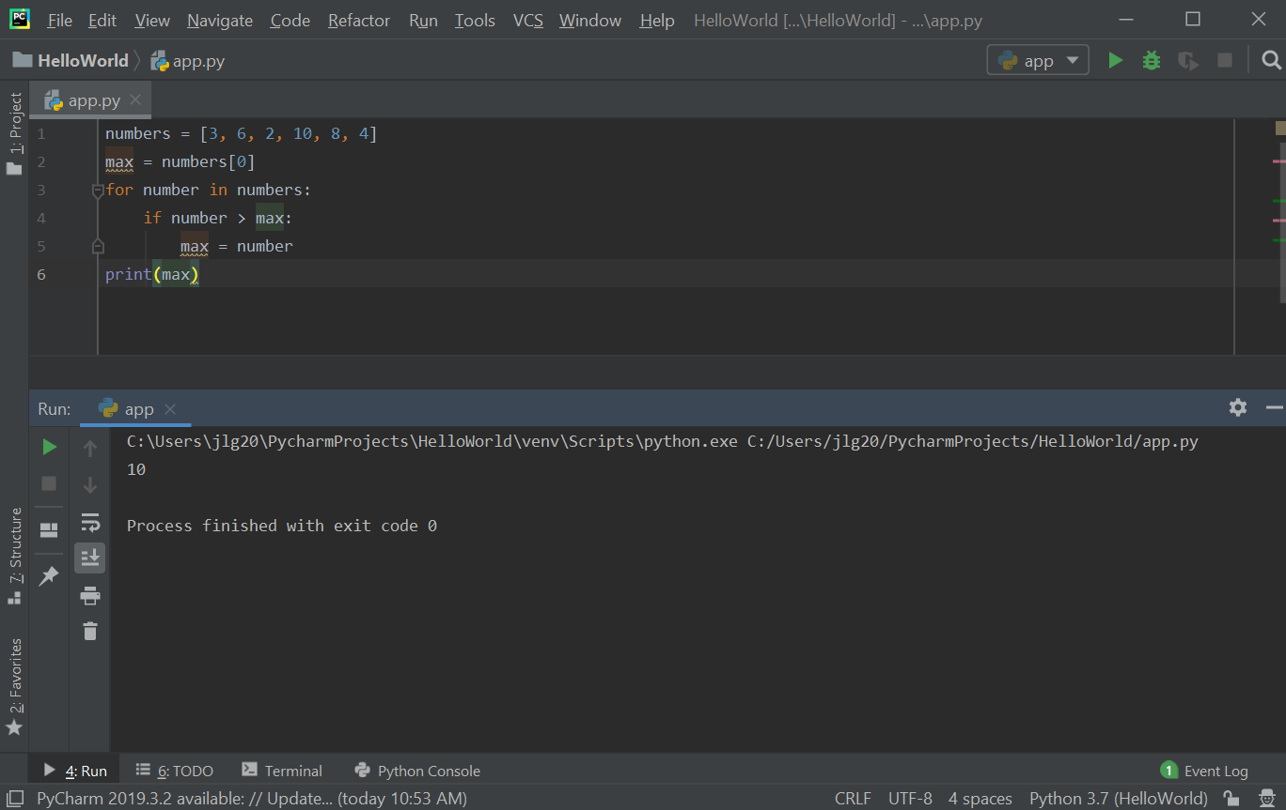

  - 2D Lists: 2D Lists: 2D lists have a lot of application in data science and machine learning. A 3-dimensional matrix (mathematics) can be represented in Python with a 2D list. 2D lists are where each item in that list is in another list. To access items in a 2D list, there is an outer list and then an inner list. The first [] refer to the outer list index and then the second [] refer to the inner list index. Nested loops can be used to iterate all the items in a 2D list.

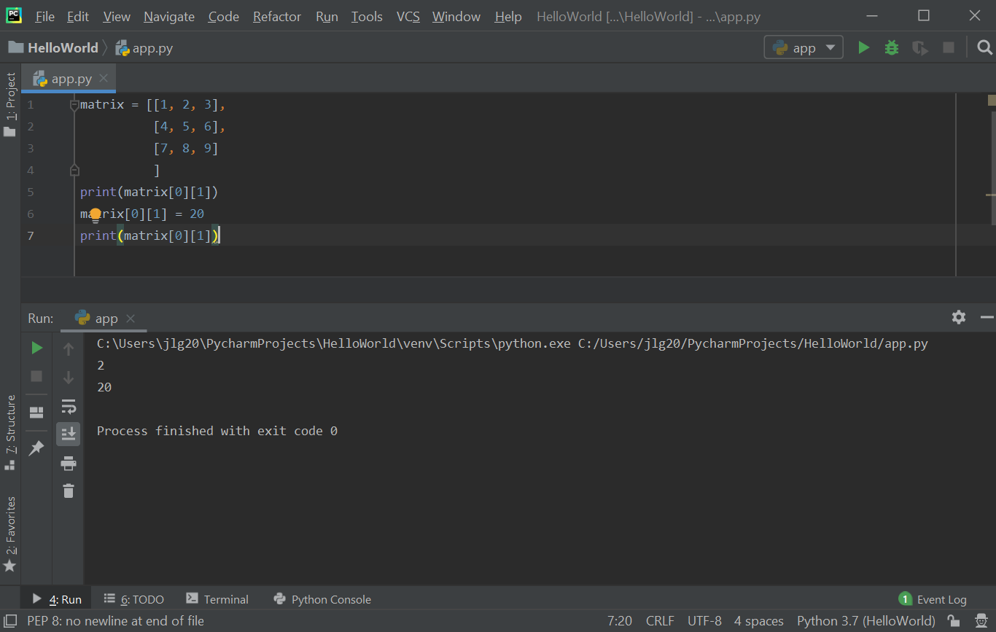

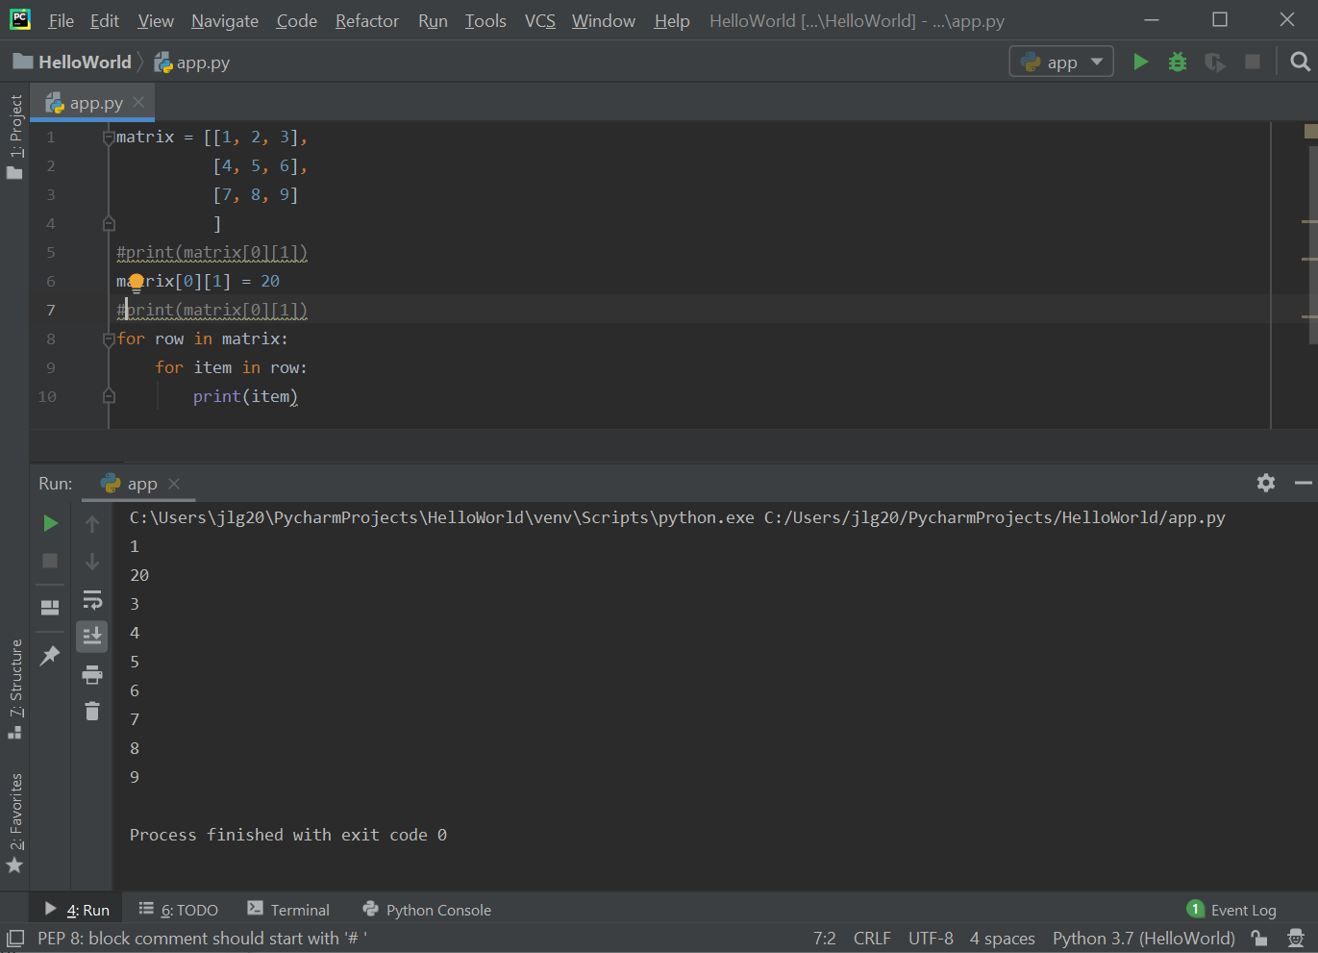

  - One example of an application of using two lists (arrays) is creating an array for suits and a second array of ranks to represent playing cards. These two arrays can then be used to create a deck of cards. The randrange() function can be used to randomly select a suit and a rank from the suits and ranks arrays, respectively.
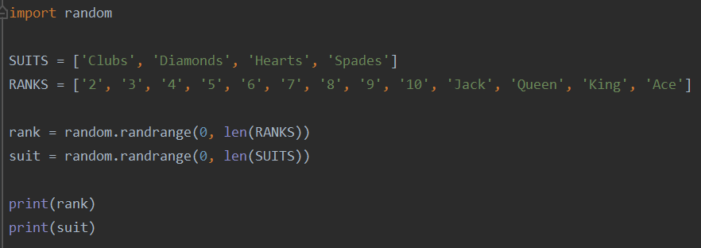

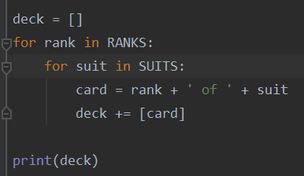
  - The deck array below is created by combining ranks and suits. The deck array will ultimately have length 52 to represent a full deck of playing cards.
Below is the output of the deck array, which show the entire deck of cards.

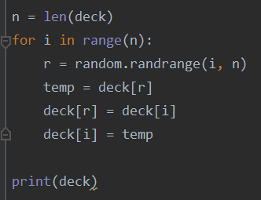
  - The code below shuffles the deck of cards by randomly selecting two cards from the existing decks array and swapping their positions. This is done n times, where n is defined as the size of the deck array.

Below is the output of the shuffling of the deck array. The cards are randomly positioned.

  - The next step is to distribute a shuffled deck of cards to players of a card game. In the code sample below, 5 cards will be distributed to each of the 3 players.

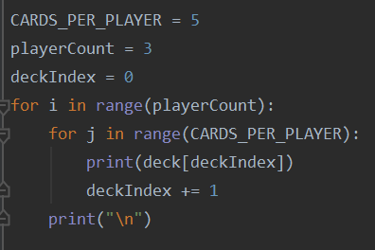

  - The shuffle algorithm used to shuffle the deck of cards above can also be applied to a 2D array. One example is to implement an in-array transpose of a 2D matrix. The code to do this is shown below.

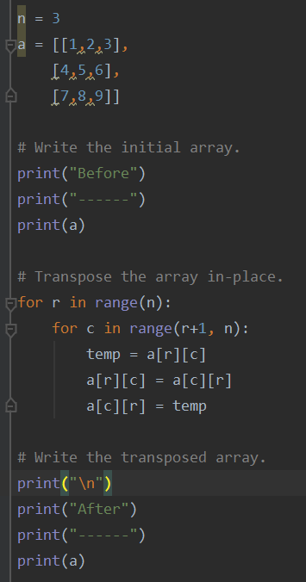

The output to the above code is shown below.

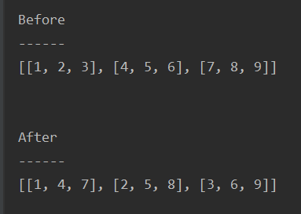

References
- Transpose: https://byjus.com/maths/transpose-of-a-matrix/

Practice Exercises
- Write a program that prints out all the elements of an array of integers that are less than a specified number. Allow the user to enter a number and print the integers of the array that are less than that number.
- Write a program that contains two lists. The program should print the elements that are common between the two lists. Test your program on two lists that are of different lengths.
- Build on top of exercise # 2 above and randomly generate the two lists and then print elements common between the two lists.

